# **Week 5 Homework:**

## Exercise #1:

Create the drawing for Part 4 from Week 2 as shown on the next page. Pay close attention to the number of decimals for each dimension, and try to think about why some features have tighter tolerances than others! PDF versions of all drawings are included in the folder called “[Drawings for Homework](https://drive.google.com/open?id=0B_Vi5ZdEzANgVHFJVGJNczc4c1E)” under the Week 5 folder:

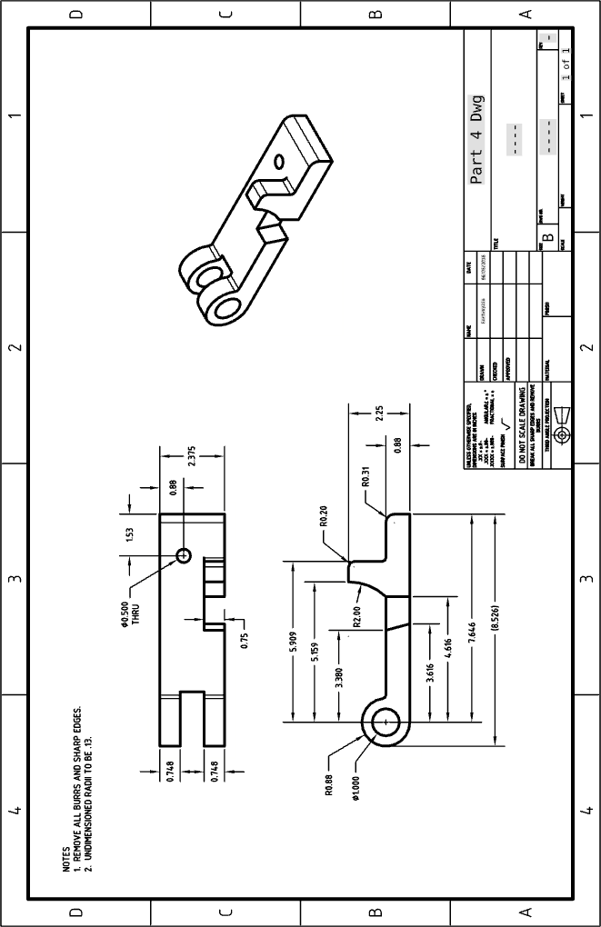

*Pro Tip: Several new, but commonly used, techniques have been utilized for this drawing.*

*(1) A note has been added in the upper left corner, using the note tool* *, to remove burrs and sharp edges, which is a standard note to have on a part that is (CNC or manually) machined. This is done for safety, believe it or not, a perfect sharp 90° corner can cut you!*

*(2) Another note has been added to callout the size of undimensioned radii. This is common when there are numerous, small radii on the part and dimensioning them would add unnecessary complexity to the drawing.*

*(3) A reference dimension (shown in parenthesis) has been added to the bottom view, by selecting the parenthesis*  *icon in the Dimension Panel. In this case, the overall length is already defined by the 0.88 radius and the 7.646 dimensions, but sometimes it is convenient to have an overall dimension on the print. Just adding the dimension would be redundant (and the tolerances would conflict with each other!), so we add parenthesis to the dimension. This means the dimension has no tolerance, and cannot be used as means for rejection (i.e. the part being out of spec).*

*(4) A “THRU” note has been added to the hole. This is common in machined parts, and should be used where necessary, and where the depth of the hole is not obvious. The Dimension Panel gives us four locations in which to type notes as needed (Above, Before, After, and Below highlighted in Blue) and it also provides some commonly used symbols as well in the drop down (Degree, Diameter, Centerline, Countersink, Depth, and Counterbore) shown here:*

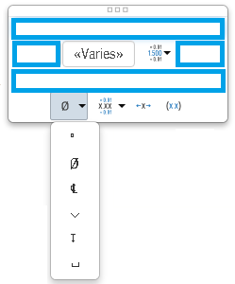

## Exercise #2:

Create the following Drawings from some of the parts in our Clamp Design. Pay close attention to the details:

1. Dimensions & number of Decimals
2. Tolerances (in Dimensions and in the Drawing Format)
3. Centerlines and Centermarks
4. Notes
5. Organized Alignment of Views & Dimensions
6. Proper display of Hidden & Tangent Lines
7. Rotation of Main views as follows (this can be done through “Properties…”):
   1. Long Arm = 49.198633 deg
   2. Short Arm = 310.801367 deg
   3. End Hinge = 97.3346257 deg
   4. Threaded Hinge = 7.3346257 deg

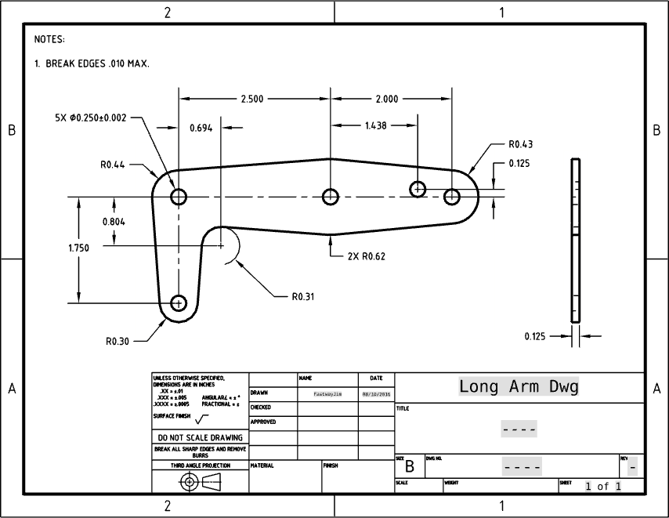 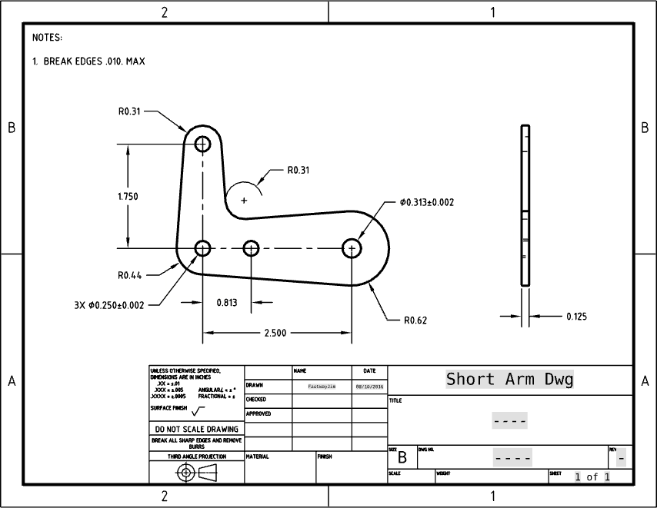

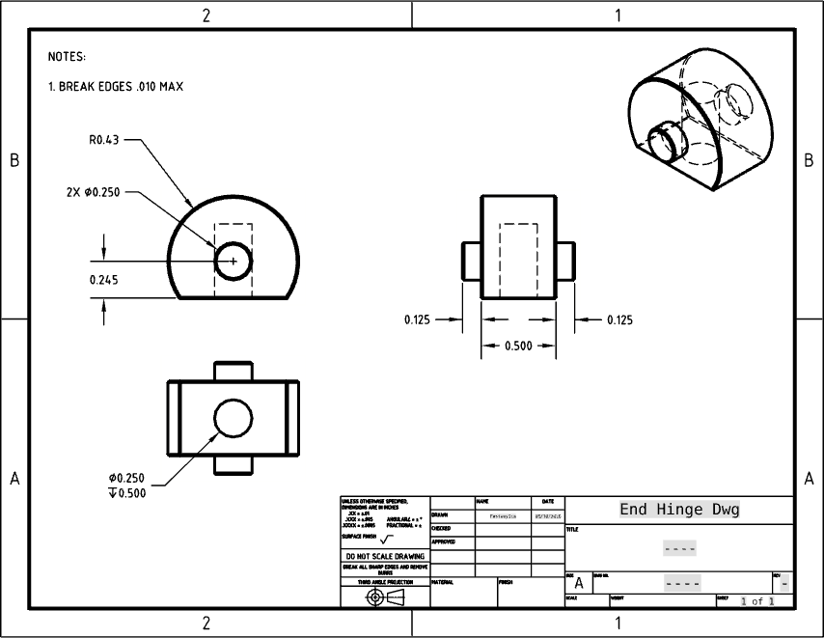 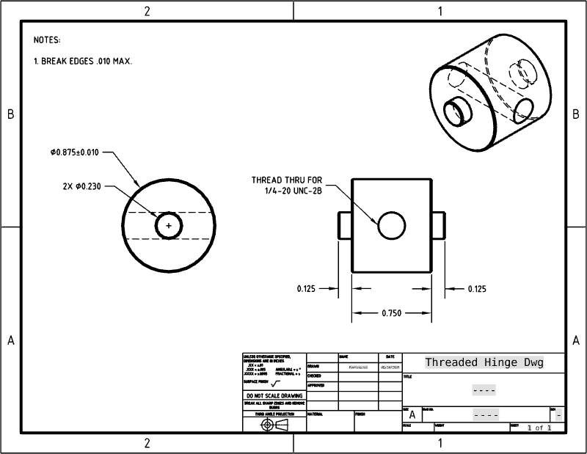

(Full-Size PDF’s can be found in the Week 5 Homework folder [HERE](https://drive.google.com/drive/u/0/folders/0B_Vi5ZdEzANgVHFJVGJNczc4c1E)).

## Exercise #3:

Create the following Assembly Drawing using the Clamp Assembly (Pay close attention to which numbered balloons are which!):

